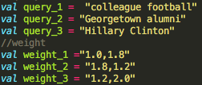

I chose colleague as 1.0 and football as 1.8, because football will be way more important than colleague. We need more information about football rather than other colleague unrelated results. For the query Georgetown and alumni, Georgetown will be more important than alumni, but alumni is still dominate a slightly heavy of weight-selected, or else maybe the search results will be Georgetown cupcake or others, so I chose Georgetown as 1.8 and alumni as 1.2. For the last query, Clinton is a very famous last name in the politic field, so that is why I set it as 2.0 and Hillary as 1.2 which is relatively unimportant.